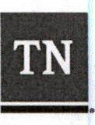
Department of
,
Education
Educator Preparation Provider/Local Education Agency
State Recognized Partnership Agreement
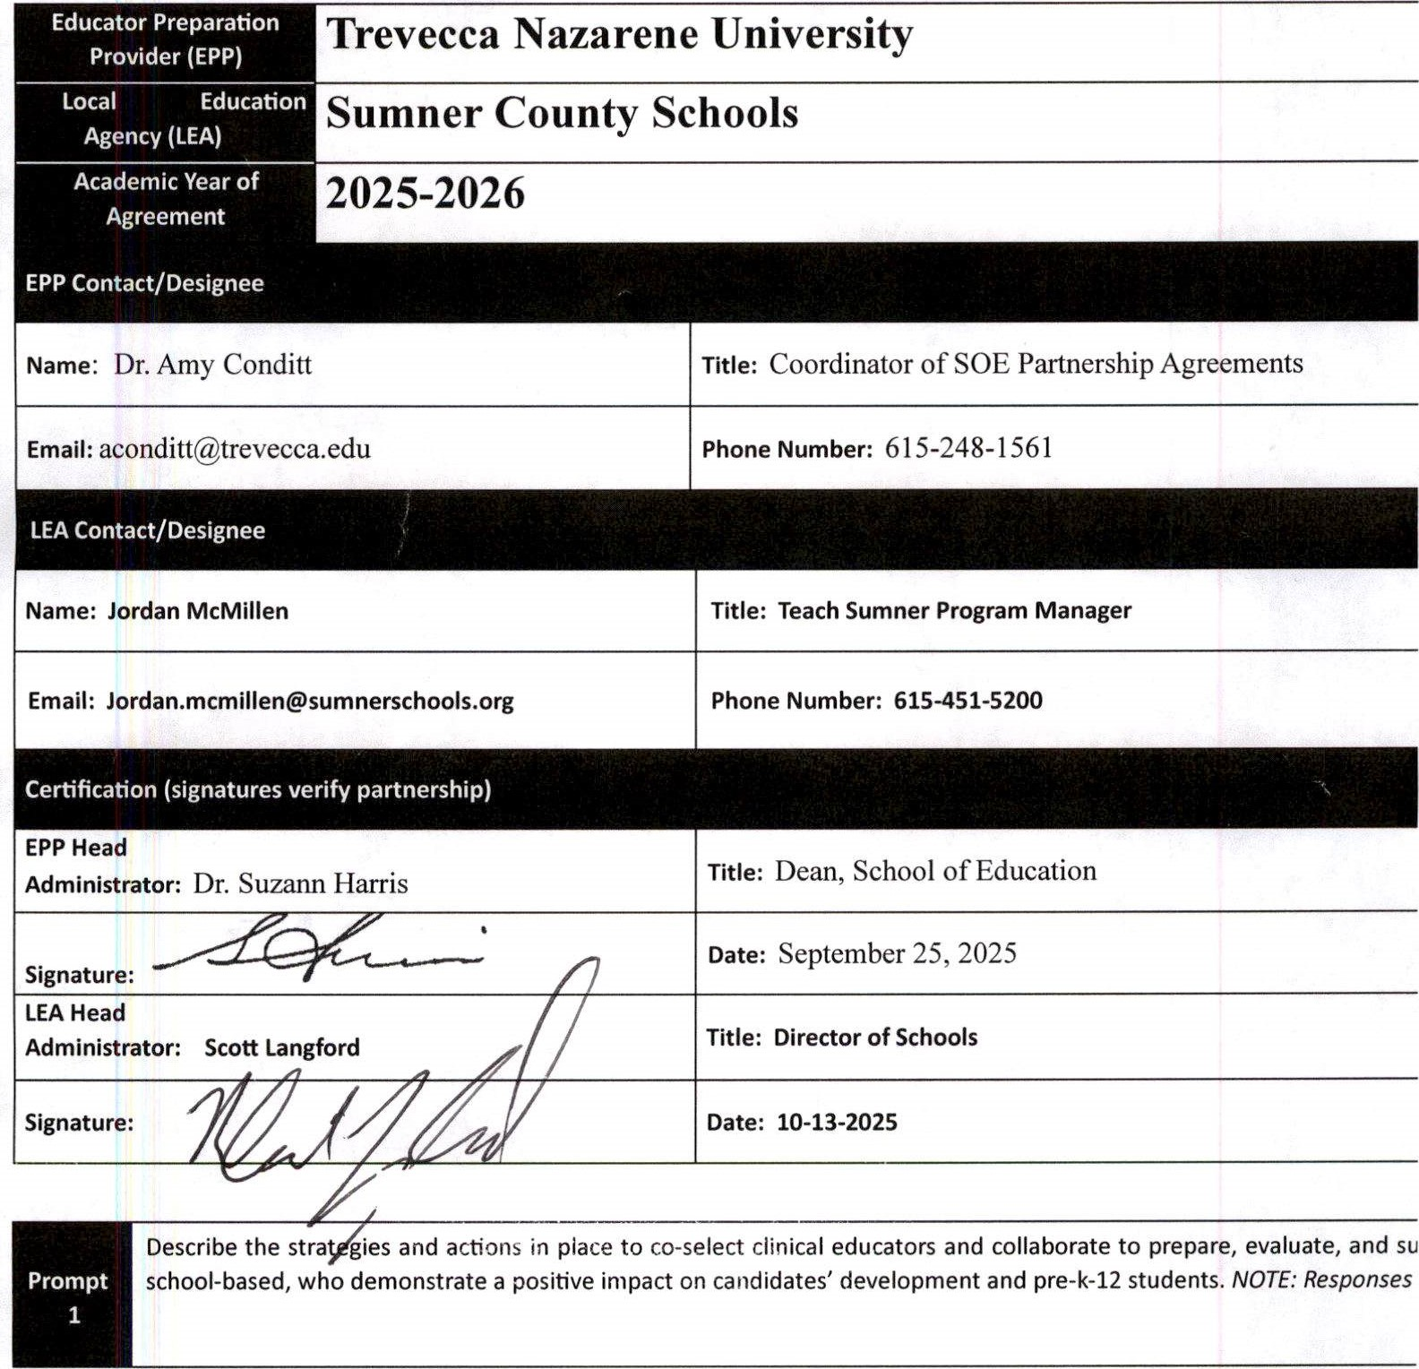Trevecca Nazarene University
Office of Educator Licensure and Preparation 1 | January 2023

