TN
Department ,a,. of
Education
Educator Preparation Provider/Local Education Agency State Recognized Partnership
Agreement
 |  | Educator Preparation Provider (EPP) |  |  |  |  | Trevecca Nazarene University
Local Education
Agency (LEA)
 |  | Academic Year of Agreement |  |  |  |  | 2025-2026
 |  | EPP Contact/Designee
 |  | Name: Dr. Amy Conditt |  |  |  |  |  | Title: Coordinator of SOE Partnership Agreements
 |  | Email: aconditt@trevecca.edu |  |  |  |  |  | Phone Number: 615-248-1561
 |  |   LEA Contact/Designee  |  |  |  |  |  | 
 |  | Name: |  |  |  |  |  | Title:
 |  | Email: |  |  |  |  |  | Phone Number:
 |  | Certification (signatures verify partnership)  EPP Head  Administrator: Dr. Suzann Harris |  |  |  |  |  | Title: Dean, School of Education
 |  | Signature: 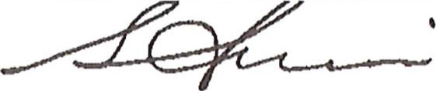 |  |  |  |  |  | Date: September 25, 2025
 |  | 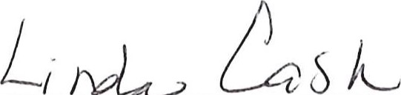  LEA Head  Administrator: |  |  |  |  |  | Title: 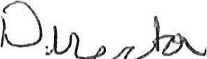 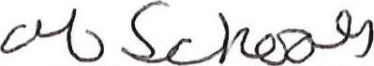
 |  | Signature:   |  |  |  |  |  | 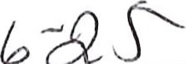  Date: ^{C} i 02
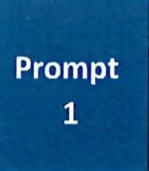 |  |  |  |  | Describe the strategies and actions in place to co-select clinical educators and collaborate to prepare, evaluate, and sup school-based, who demonstrate a positive impact on candidates' development and pre-k-12 students. NOTE: Responses
 |  |  | Office of Educator Licensure and Preparation |  |  |  |  |  | I January 2023
 |  |  |  | TN |  | Department of
Ga Field Experiences in the Initial Level Programs include Traditional Undergraduate at Candidates in these programs have been granted security clearance for the consideration of working and/or student teaching classroom experiences under the Tennessee Code Annotated Book 9, Sections 37
The Clinical (Student) Teaching Experience for these candidates takes place over 13 weeks at the consecutive days). Placements are co-selected, and it has been agreed that Cooperating eachers meet the
Three years of teaching experience
Recipient of Level 4 or Level 5 teaching on TEAM during the previous school year Recommendation from building level administrator
Willingness to serve as a mentor
Prior mentor evaluation data
Field Experiences at the Initial Level are outlined in a handbook and described in course syllabi. The number of hours above-mentioned Cooperating Teacher criteria apply. Parameters of each unique Field Experience are ex] experience. These experiences benefit the candidates, the school/community, and the faculty. This relatio focus of developing candidate effectiveness in creating environments to support all students' learning anc
Clinical experiences in Advanced Programs include Educational Leadership, Library and Informational Science, Curl Learners. Experiences are carefully planned to provide candidates with sufficient depth, breadth, diversity, coherence for continuous improvement at this level include but are not limited to, the development of a no-cost on-line professi( teachers and administrators across the state with the transition to virtual teaching; action-based research projects, and Department of Education that offers a grant for applicants to receive Special Education and English as a Second Lang
Concerning the evaluation of Cooperating Teachers and University Supervisors, candidates complete an evaluation fc revised based on feedback received during Partnership and Advisory Council Meetings. Data from the Mentor Evalue shared with partners, and considered regarding future placements.
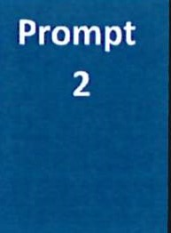 |  |  |  |  | Describe the design and implementation of clinical experiences, utilizing various modalities, of sufficient depth, breadth, candidates demonstrate their developing effectiveness and positive impact on pre-k-12 students (For instructional leader opportunities for candidates to practice applications of content knowledge and skills.). NOTE: Responses should not excee

Office of Educator Licensure and Preparation 2 I January 2023
 | TN | Department of
Trevecca works with partners to design a variety of experiences that support the candidates' development of knowled; uses various modalities which helps candidates demonstrate their developing effectiveness and positive impact on pre
To ensure licensure candidates are afforded a variety of experiences certain criteria are outlined and detailed in course dialogue between university and school-based faculty with candidates prior to, during, and after field experiences or c on-site in the school building while many professors and the Director of Clinical Placements maintain relationships w so that candidates are ensured a quality experience.
ical and Field Experiences candidates are granted security clearance for the consideration of working with P-12 studel teaching classroom experiences under the Tennessee Code Annotated Book 9, Sections 37-1-408, 71-3-501. Clinical h Field Experience Team and reflect diverse classroom/school settings. Candidates' experiences in the field facilitate thc offering opportunities to observe and participate in a variety of ways within a school setting. During field experiences with school personnel, students or families, participate in education-related community events, attend school board or school professionals. Best practices including literacy strategies and action-based research are embedded in Advancec experiences where they observe and practice strategies as well as collaborate with teachers and administrators. Togetk to design effective curriculum and utilize data for improved student learning field experiences in all programs are assc partners with an instrument aligned to the Tennessee Educator Acceleration Model (TEAM) rubric.
Lastly, during Advisory Board meetings partners provide valuable input concerning the development and monitoring and initiatives within the P-12 environment. Furthermore, partners offer guidance concerning transition points such provide valuable input at the data retreat.
Cli
3
Office of Educator Licensure and Preparation I January 2023

