

Education

Educator Preparation Provider/Local Education Agency State Recognized Partnership Agreement

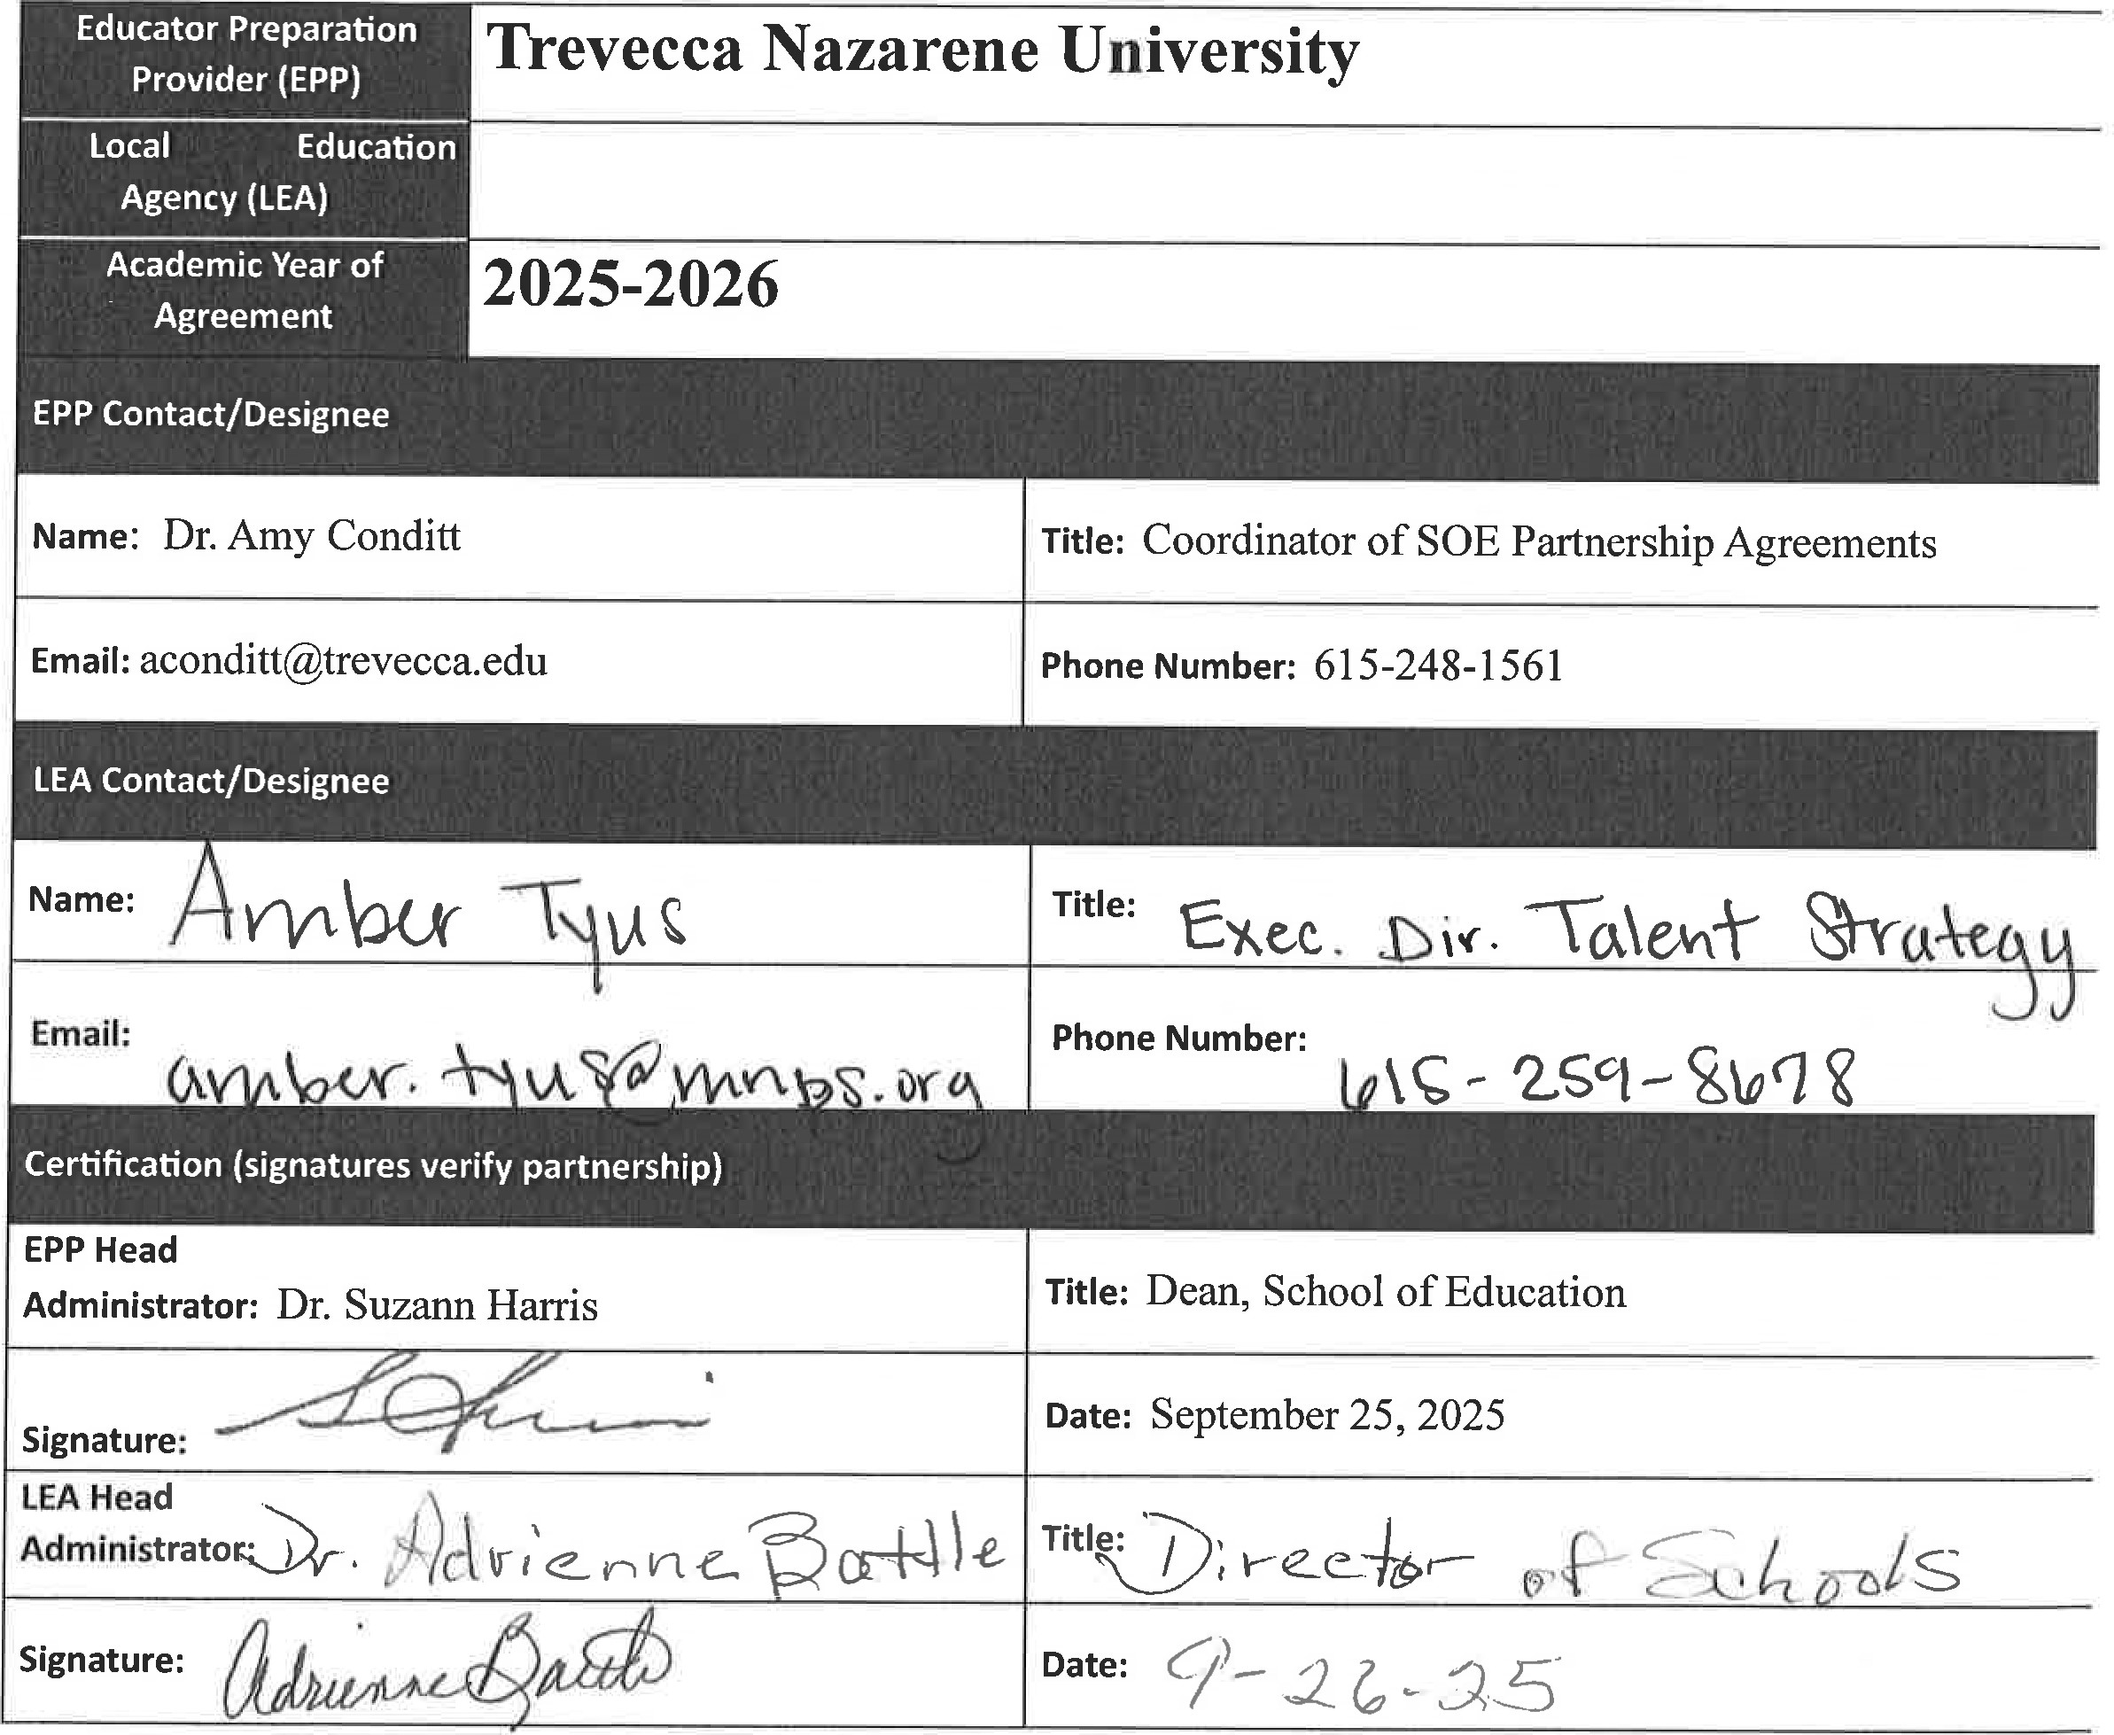

|  |  |
| --- | --- |
|  | Describe the strategies and actions in place to co-select clinical educators and collaborate to prepare, evaluate, and st school-based, who demonstrate a positive impact on candidates' development and pre-k-12 students. NOTE: Responses |



|  |
| --- |
| TN |

Department B of

# Education

|  |
| --- |
| Clinical and Field Experiences in the Initial Level Programs include Traditional Undergraduate and Mas in these programs have been granted security clearance for the consideration of working with P-12 st teaching classroom experiences under the Tennessee Code Annotated Book 9, Sections 37- I -408,71-3-:  The Clinical (Student) Teaching Experience for these candidates takes place over 13 weeks at the end of days). Placements are co-selected, and it has been agreed that Cooperating eachers meet the following (   * Three years of teaching experience * Recipient of Level 4 or Level 5 teaching on TEAM during the previous school year  Recommendation from building level administrator * Willingness to serve as a mentor Prior mentor evaluation data   Field Experiences at the Initial Level are outlined in a handbook and described in course syllabi. The number of hoc above-mentioned Cooperating Teacher criteria apply. Parameters of each unique Field Experience are e experience. These experiences benefit the candidates, the school/community, and the faculty. This relat focus of developing candidate effectiveness in creating environments to support all students' learning a]  Clinical experiences in Advanced Programs include Educational Leadership, Library and Informational Science, Cu Learners. Experiences are carefully planned to provide candidates with sufficient depth, breadth, diversity, coherenc for continuous improvement at this level include but are not limited to, the development of a no-cost on-line profess teachers and administrators across the state with the transition to virtual teaching; action-based research projects, an Department of Education that offers a grant for applicants to receive Special Education and English as a Second Lai  Concerning the evaluation of Cooperating Teachers and University Supervisors, candidates complete an evaluation revised based on feedback received during Partnership and Advisory Council Meetings. Data from the Mentor Evall shared with partners, and considered regarding future placements. |



|  |
| --- |
| TN |

# Education

Describe the design and implementation of clinical experiences, utilizing various modalities, of sufficient depth, breadth

Prompt demonstrate their developing effectiveness and positive impact on pre-k-12 students (For instructional leader programs candidates to practice applications of content knowledge and skills.). NOTE: Responses should not exceed one page per

Trevecca works with partners to design a variety of experiences that support the candidates' development of knowle uses various modalities which helps candidates demonstrate their developing effectiveness and positive impact on p

To ensure licensure candidates are afforded a variety of experiences certain criteria are outlined and detailed in cour dialogue between university and school-based faculty with candidates prior to, during, and after field experiences 01 on-site in the school building while many professors and the Director of Clinical Placements maintain relationships so that candidates are ensured a quality experience.

cal and Field Experiences candidates are granted security clearance for the consideration of working with P-12 stud teaching classroom experiences under the Tennessee Code Annotated Book 9, Sections 37-1-408,71-3-501. Clinical Field Experience Team and reflect diverse classroom/school settings. Candidates' experiences in the field facilitate t offering opportunities to observe and participate in a variety of ways within a school setting. During field experienci with school personnel, students or families, participate in education-related community events, attend school board school professionals. Best practices including literacy strategies and action-based research are embedded in Advanc experiences where they observe and practice strategies as well as collaborate with teachers and administrators. Toge to design effective curriculum and utilize data for improved student learning field experiences in all programs are as partners with an instrument aligned to the Tennessee Educator Acceleration Model (TEAM) rubric.

Lastly, during Advisory Board meetings partners provide valuable input concerning the development and monitorin and initiatives within the P-12 environment. Furthermore, partners offer guidance concerning transition points suc provide valuable input at the data retreat.



|  |
| --- |
| TN |

Department of

# Education

4 | January 2023