Policy Title: Policies and Procedures for Remediation and Assessment

APR-PA Accreditation Standards for Physician Assistant Education, 6th Edition
Standards Addressed: A3.14c
Approved by: Program Director & Faculty
Approval Date: 04.01.2025
Effective Date: 05.01.2025
Last Reviewed: 04.01.2025
Next Review: April 2026

ARC-PA Standard(s) Addressed

A3.14 The program publishes, consistently applies, and makes readily available to enrolled and prospective students:

c) policies and procedures for remediation

Policy
The TNU PA Program is dedicated to student success. Remediation may be required at any point in the Program if a student demonstrates deficiencies in academic knowledge, clinical skills, or professionalism. The goal of the remediation process is early identification of students who encounter challenges in these areas and to address deficiencies in a timely manner.

Didactic phase
Remediation Policy
If a student fails to earn a grade of 75 or above on a clinical skill assessment, a designated written assignment, or a written exam, the student will be required to remediate that assessment. The student will meet with the course instructor and a remediation plan will be developed using the applicable Post-Exam or Post-Clinical Exam Performance Analysis Form. The Student Academic Mentoring Form may also be used in addition to the previous forms.

Reassessment Policy
If a student fails to earn a grade of 75 or above on a written exam, clinical skill assessment or a designated written assignment, the student will be required to complete a reassessment.

- If a student passes a clinical skill/check-off reassessment, the student will not be awarded a new score, and the original grade will stand. To pass the class, a student must show proficiency in the clinical skill/check-off being assessed. The instructor will complete the Clinical Skills Remediation Performance Form.
- If a student has a passing grade on a clinical skill assessment/check-off but still shows significant deficiencies in clinical skills, they may be required to repeat the assessment in order to demonstrate proficiency. The original grade will stand. The instructor will complete the Clinical Skills Remediation Performance Form.

- If a student earns between 70 and 74 on a written exam and has a passing grade in the course after the exam, he/she may choose whether or not to complete a reassessment exam. The reassessment date is typically set within one to two weeks after the original exam. If the student chooses not to complete the reassessment exam, there will be no future opportunity to do so. If a student is eligible to opt-out of a reassessment exam, he/she is required to do so within one week of the exam grades being posted by meeting with the course instructor and signing the Reassessment Form.
- If a student fails to earn a grade of 75 on a written exam and has a failing grade in the course after the exam, he/she will be required to complete a reassessment exam.
- Students who earn below 70 on a written exam will also be required to complete a reassessment exam regardless of their overall course grade.
- If a student successfully completes a written reassessment, he/she will receive a 75 for that exam or assessment.
- All final exams and all Cadaver lab exams are not covered under this Reassessment Policy.

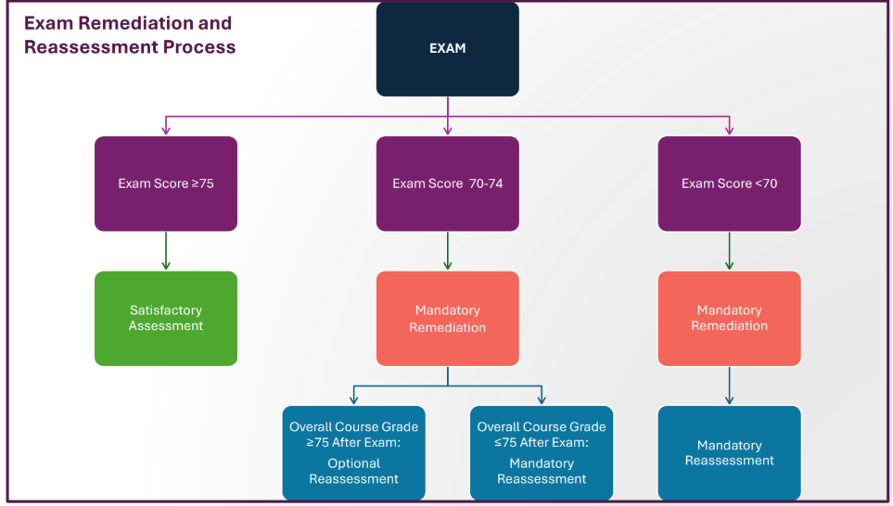

- If a student has a failing grade in the course prior to the final exam, and it is mathematically impossible to earn a passing grade for the course, the student must meet with the Student Progress Committee to determine next steps which may include academic probation or dismissal from the Program.
- If a student fails to achieve a final course grade of 75 after the final course exam, they may be offered a remediation plan and a comprehensive reassessment exam.
- The remediation plan will include an Academic Improvement Plan (AIP). For the AIP, the student will review/relearn course content and missed topics and review test-taking preparation and strategies.
- The purpose of the comprehensive reassessment exam is to provide the student with an opportunity to demonstrate proficiency in the course material and correction of any deficiencies in knowledge and skills.
- The SPC will determine whether to offer a comprehensive reassessment exam based on the student’s overall academic and professional performance in the Program. There is no guarantee that a comprehensive reassessment exam will be offered to the student.
- If a comprehensive course reassessment is offered by the SPC, the student must earn a 75 or higher in order to successfully complete the course. If successful, their final course grade will be adjusted to a 75 or C.
- The highest final course grade possible for a student who successfully completes a comprehensive reassessment exam is a C (75).
- The student will be placed on academic probation following successful completion of the reassessment exam.
- Failure of the comprehensive course reassessment will result in referral to the SPC for deceleration (if one course failure) or dismissal (if two course failures).

Didactic Summative Evaluation Remediation and Reassessment
A student who fails the Didactic Summative Evaluation must meet with the Student Progress Committee to discuss a remediation plan. The remediation will take place immediately following the summer II semester of the didactic phase. This remediation process may delay the student’s progression to the clinical phase and their first Supervised Clinical Experience. During remediation, the student must actively engage in prescribed learning activities and demonstrate measurable improvement through formative assessments, faculty feedback, or other program established criteria.

At the end of the remediation period, the student must complete a didactic summative reassessment utilizing an Objective Structured Clinical Examination (OSCE) with standardized patient(s) and a written examination. On successful completion of the remediation plan and reassessment, the student will then begin the clinical phase with a possible delayed Program graduation date. Failure to meet remediation requirements and/or pass the reassessment will result in dismissal from the Program.

Clinical phase
Remediation and Reassessment Policy
If a student fails to earn at least the minimum passing score on a clinical skill assessment, a graded rotation assignment (SOAP note, case presentation, etc.), or a graded written exam, the student will be required to remediate that assessment. The student will meet with their advisor and/or course instructor to develop a remediation plan. The student must complete a reassessment with a minimum passing score of 75 or higher on graded assignments and assessments, unless otherwise specified for a particular item.

EOR Exam Remediation Policy
If a student falls below the set program passing score (see EOR Exam Grading) for a given end of rotation (EOR) exam, the student will meet with the Student Progress Committee and remediation will be as follows:

- EOR exam remediation and reassessment will consist of counseling with a Clinical Team member and/or faculty advisor to identify areas of deficiency, reviewing supplemental study material, and taking a reassessment examination. The SPC may require additional assignments to be completed by the student as part of the remediation process.
- The remediation process and reassessment must be completed within no more than 7 - 10 days (not including end-of-semester breaks) following the exam failure, unless there are extenuating circumstances, as determined by the SPC. This allows the Program to identify and address student deficiencies in a timely manner (ARC-PA Standard B4.01b).
- The student will receive an incomplete grade for the course until the reassessment exam has been completed. The student will continue to progress in their remaining rotations while completing the remediation and reassessment process. If the student successfully completes the remediation process and passes the reassessment exam, the maximum overall rotation grade that can be achieved will be 75% or C.
- If a student fails the reassessment exam, the student will receive a failing grade (F) for the rotation and must meet with the SPC to determine next steps. This may include, but is not limited to the following:
- Academic probation.
- Formulation of a remediation plan, which will include repeating the failed rotation at the conclusion of the clinical year (this will result in a delay in graduation along with additional tuition).
- Dismissal from the Program.

Clinical Rotation Failure, Remediation, and Reassessment Policy
If any of the following occurs, the student will fail the rotation (receive a course grade of F):

- Failure of an EOR Exam reassessment (score of <75%).

- Failure of the Final Preceptor Evaluation of Student (score of <75% and/or score of 1 [jeopardizing patient safety] on ANY items on the evaluation).
- Final rotation scores below 75%.
- Professionalism infraction(s) determined by the SPC to warrant course failure (see Professionalism Policy).
- Failure to successfully complete any of the pass/fail requirements of the course.

If a student fails a rotation, the student will be required to meet with the SPC to determine a corrective course of action which may include the following:

- Academic probation.
- Formulation of a remediation plan, which will include repeating the failed rotation at the conclusion of the clinical year (this will result in a delay in graduation along with additional tuition). This may also include completing additional coursework/assignments as determined by the SPC.
- Dismissal from the Program.

Inability to complete rotation: Any student who is unable to complete a clinical rotation due to extenuating circumstances, such as major illness or injury, will be required to complete the entire rotation at the end of the scheduled clinical year. The student should note that this will result in a delay in graduation and additional tuition. A grade of withdrawal will be recorded until the rotation is repeated. (See Leave of Absence).

Serious Student Deficiencies: If the preceptor or faculty member identifies a serious deficiency in any area of the student’s performance, including professionalism, the clinical committee will investigate the matter and take action based on their findings, regardless of the student’s calculated grade for a rotation. Actions may range from counseling the student to recommending dismissal from the Program with final decisions referred to the Student Progress Committee.

Clinical Formative OSCE Remediation and Reassessment Policy
A student who fails a clinical formative OSCE (score of <80%) will be required to meet with the SPC to discuss a remediation plan and reassessment. The remediation and reassessment will take place prior to beginning the Program Summative Evaluation (EOR 6) without interfering with progression in the student’s SCPEs. During the remediation period, the student will need to demonstrate progress in their areas of deficiency. The student will need to successfully pass (score of ≥80%) the reassessment OSCE as a requirement for completion of this course and progression to the Program Summative Evaluation.

Failure to demonstrate satisfactory progression or to pass the clinical formative OSCE reassessment will result in a meeting with the Student Progress Committee (SPC) to determine possible outcomes including delayed program graduation or dismissal.
For Structured Clinical Practice Experience (SCPE) Student Visit and Final Preceptor Evaluation of Student Remediation policies, please see the information in Section – 8 Clinical Phase Policies and Guidelines.

Program Summative Evaluation Remediation and Reassessment Policy
If a student fails any of the sections of the Program Summative Evaluation, they will be required to meet with the Student Progress Committee to discuss next steps.

- The first failure of a section of the exam will result in remediation and reassessment of the failed section.

- The remediation for any of the sections, except the PAEA End of Curriculum (EOC) exam or the Research Capstone project, will take place during the six (6) weeks immediately following the Program summative evaluation without interfering with the student’s SCPE.

- The remediation for the PAEA End of Curriculum (EOC) exam will occur at least 60 days after the first attempt in accordance with PAEA policy.

- If remediation of the Research Seminar Capstone project is required, a deadline for resubmission of a revised paper will be established at the SPC meeting.

- Following the remediation period, the student must demonstrate proficiency in the identified area of deficiency by successfully completing a reassessment of the failed section of the Program summative evaluation.

- On successful completion of the remediation plan and reassessment, the student will continue to complete the remaining requirements of the clinical phase without resulting in a delayed program graduation date.

- The second failure of a section of the examination will result in an up to 6-week comprehensive remediation, which will result in a delayed graduation (December) and costs incurred.

- During the remediation period, the student will need to demonstrate progress in areas of deficiency.

- The student will be required to successfully complete a reassessment of the failed section of the Program summative evaluation.

- On successful completion of the remediation plan and reassessment, the student will continue to complete the remaining requirements of the clinical phase.

- Failure to demonstrate satisfactory progression and/or failure of the second program summative reassessment will result in dismissal from the Program.

Academic Improvement Plan (AIP)
All students requiring remediation for a course are required to meet with the course director to discuss or develop an AIP. AIP meetings are initiated for one of the following reasons:

- Academic warning or academic probation.
- Referral from the Student Progress Committee (SPC).
- Referral from student’s advisor, course director, or Program Director.
- Student self-referral

The course director will meet with the student to review their performance and develop an AIP, documented on the Academic Improvement Plan Form. The student is required to complete the AIP. Failure to do so may result in referral to the Student Progress Committee (SPC) for further action, which could include deceleration or dismissal. Participation in an AIP is mandatory for all students on academic warning or probation.

