 •

Educator Preparation Provider/Local Education Agency State Recognized Partnership Agreement

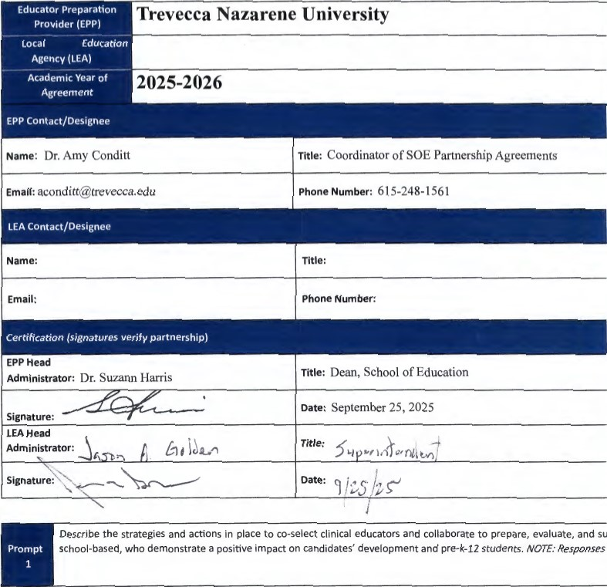

Of a

# TN



|  |
| --- |
| Clinical and Field Experiences in the Initial Level Programs include Traditional Undergraduate and Mast in these programs have been granted security clearance for the consideration of working with P-12 sti teaching classroom experiences under the Tennessee Code Annotated Book 9, Sections 37-1-408,71-3-5  The Clinical (Student) Teaching Experience for these candidates takes place over 13 weeks at the end of days). Placements are co-selected, and it has been agreed that Cooperating eachers meet the following c  e Three years of teaching experience   * Recipient of Level 4 or Level 5 teaching on TEAM during the previous school year * Recommendation from building level administrator * Willingness to serve as a mentor * Prior mentor evaluation data   Field Experiences at the Initial Level are outlined in a handbook and described in course syllabi. The number of hou above-mentioned Cooperating Teacher criteria apply. Parameters of each unique Field Experience are e: experience. These experiences benefit the candidates, the school/community, and the faculty. This relati focus of developing candidate effectiveness in creating environments to support all students' learning ar  Clinical experiences in Advanced Programs include Educational Leadership, Library and Informational Science, Cu Learners. Experiences are carefully planned to provide candidates with sufficient depth, breadth, diversity, coherenc for continuous improvement at this level include but are not limited to, the development of a no-cost on-line profess teachers and administrators across the state with the transition to virtual teaching; action-based research projects, an' Department of Education that offers a grant for applicants to receive Special Education and English as a Second Lan  Concerning the evaluation of Cooperating Teachers and University Supervisors, candidates complete an evaluation i revised based on feedback received during Partnership and Advisory Council Meetings. Data from the Mentor Evan shared with partners, and considered regarding future placements. |

of

|  |
| --- |
| TN |

## D . ,



Describe the design and implementation of clinical experiences, utilizing various modalities, of sufficient depth, breadth, demonstrate their developing effectiveness and positive impact on pre-k-12 students (For instructional leader programs,

Prompt

candidates to practice applications of content knowledge and skills.). NOTE: Responses should not exceed one page per

Trevecca works with partners to design a variety of experiences that support the candidates' development of knowle( uses various modalities which helps candidates demonstrate their developing effectiveness and positive impact on PI

To ensure licensure candidates are afforded a variety of experiences certain criteria are outlined and detailed in cours dialogue between university and school-based faculty with candidates prior to, during, and after field experiences or on-site in the school building while many professors and the Director of Clinical Placements maintain relationships so that candidates are ensured a quality experience.

ical and Field Experiences candidates are granted security clearance for the consideration of working with P-12 studi teaching classroom experiences under the Tennessee Code Annotated Book 9, Sections 37-1-408,71-3-501. Clinical Field Experience Team and reflect diverse classroom/school settings. Candidates' experiences in the field facilitate tl offering opportunities to observe and participate in a variety of ways within a school setting. During field experience with school personnel, students or families, participate in education-related community events, attend school board ( school professionals. Best practices including literacy strategies and action-based research are embedded in Advance experiences where they observe and practice strategies as well as collaborate with teachers and administrators. Togel to design effective curriculum and utilize data for improved student learning field experiences in all programs are as: partners with an instrument aligned to the Tennessee Educator Acceleration Model (TEAM) rubric.

Lastly, during Advisory Board meetings partners provide valuable input concerning the development and monitorin and initiatives within the P-12 environment. Furthennore, partners offer guidance concerning transition points sucJ provide valuable input at the data retreat.

of